PROJECT PLANNING PHASE

Planning Logic

Introduction

Planning is an essential phase that defines the sequence of activities required to successfully implement the project. The planning logic ensures that every module is developed systematically, tested thoroughly, and integrated efficiently within the ServiceNow platform.

Planning Logic

The project follows a structured implementation process:

1. Requirement Gathering

- Understand organizational access management requirements.
- Identify user, group, role, and security requirements.

2. System Design

- Design user management process.
- Plan group hierarchy.
- Design role structure.
- Define Access Control Lists (ACLs).
- Design workflow automation.

3. Development

- Create users.
- Create groups.
- Create and assign roles.
- Configure ACLs.
- Develop workflows using Flow Designer.

4. Testing

- Verify user creation.
- Test group assignments.
- Validate role permissions.
- Test ACL security.
- Verify workflow execution.

5. Deployment

- Deploy the solution into the ServiceNow instance.
- Perform final validation.

6. Maintenance

- Monitor system performance.
- Update roles and permissions when required.
- Maintain security policies.

Planning Objectives

- Develop the system in a structured manner.
- Reduce implementation risks.
- Ensure secure user management.
- Deliver the project on schedule.
- Improve operational efficiency.

Conclusion

The planning logic provides a clear roadmap for implementing secure and automated user, group, role, ACL, and workflow management within the ServiceNow platform.

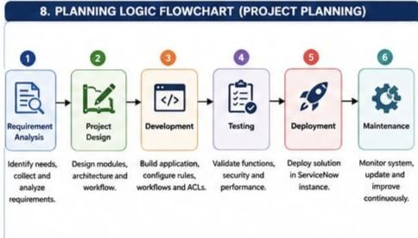

Project Planning

Project Schedule

Phase| Activity| Expected Outcome
Phase 1| Requirement Analysis| Requirements identified
Phase 2| System Design| Solution architecture prepared
Phase 3| User & Group Creation| Users and groups configured
Phase 4| Role & ACL Configuration| Secure access implemented
Phase 5| Workflow Development| Automated approvals configured
Phase 6| Testing| System validated
Phase 7| Deployment| Project successfully implemented

Resource Planning
Software Resources

- ServiceNow Personal Developer Instance
- Flow Designer
- Access Control Lists (ACLs)
- ServiceNow Studio
- Notification Service

Hardware Requirements

- Computer/Laptop
- Stable Internet Connection

Human Resources

- Project Developer
- System Administrator
- End Users
- Project Guide/Mentor

Risk Management

Risk| Solution
Incorrect role assignment| Test role mapping before deployment
Unauthorized access| Configure and validate ACLs
Workflow failure| Perform workflow testing
Data inconsistency| Validate user records before deployment

Deliverables

- User Management Module
- Group Management Module
- Role Management Module
- Access Control Configuration
- Workflow Automation
- Project Documentation
- Testing Report

Conclusion

Proper planning ensures the project is completed efficiently while maintaining security, quality, and timely delivery. The planned activities help achieve a reliable ServiceNow solution for user and access management.

